

2016 IHSA Regional Championships
Saturday, October 22, 2016
Washington Park, 57th St and Russell Drive, Chicago, IL 60637
Weather: Nice, High-50’s to Low-60’s at race time

Directions (from Jones): I-90 E to Garfield Blvd (Exit 57), Left on Garfield, Garfield turns in to Morgan, Right on Russell Drive
(see website for better/easier directions)

Schedule
1:45 - p.m. – Meet at Washington Park/Set-up Camp
2:00 p.m. – Coaches Meeting
2:30 p.m. – Girls Regional Championship Race (3.0 miles)
2:40 p.m. – Warm-up
2:50 p.m. – SDS
3:00 p.m. – To Start Line (Strides, Huddle)
3:15 p.m. – Boys Regional Championship Race (3.0 miles)
4:00 p.m. – Awards Ceremony
4:15 p.m. – Approximate Conclusion of Meet
**Cool-downs of 10+ minutes are to be done within 5 minutes of finishing your respective race

Focuses: Making sure we are on for 2 miles (not letting the 2nd mile sag) and then just grinding and fighting like hell that 3rd mile; finishes from 400m out

Other Notes: Due to a later race time, you should wake up no later than 9 a.m. and preferably get a 10-15 minute “shakeout” run in. Do not change up your schedule (eating and/or sleeping) more than a half-hour or so just because of the later race time. Keep everything as close to routine as possible. Set your alarm clock still.
-The course is the exact same as the CPL Championship 3 Miles Course (start and finish line may be different)
-Look sharp and put together at all times. If wearing any extra layers, everything is under the warm-up jacket. ¼ Zips, team hoodies, dri-fits are preferable for under jacket. If wearing a hat, wear a solid neutral color hat or a JCPXC/TF hat
-Remember that no transportation is provided to or from the meet, please plan accordingly
-We would prefer that all Top-12 runners are in attendance, whether competing or not, but please speak to me if there is an issue

_________________

“It’s baseball brother, don’t ever let the pressure exceed the pleasure” – Joe Maddon

“Hit a home run - put your head down, drop the bat, run around the bases, because the name on the front is more - a lot more important than the name on the back” – Ryne Sandberg

2.5
1
400 left
2
200 left
1.5
GRIT

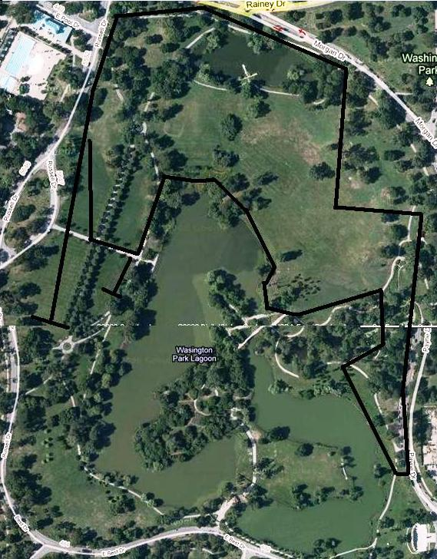
1.5
1
2
200L
400L
800 left

Regional Championship Course (3.0 Miles = 2 Full Loops) ( - - - - - = New Start/Finish Line)
*Course now goes AROUND the bridge

