Joliet West Dual Meet
401 N Larkin Ave, Joliet, IL 60435
BUS LEAVES 2:45
4:15 Girls Race
4:45 Boys Race
PCHS Entries
Emrath | Adelmann | Bonomo | Eubanks | Hale | Forbear
Mulyk | DeAvila | Rojo | Schick | Torri | Graefen
Obman | Kacena | Bradley | Matula | Edmondson | Matson
Kodura | Kawa | Ruane | Ensworth | Herrera | Ju, Irizarry
Jo Irizarry | Koukou | Porn | Rodriguez | Fannin | Weyer
Konow
Not Racing: Wyckoff, Worden, Solis, Mendoza

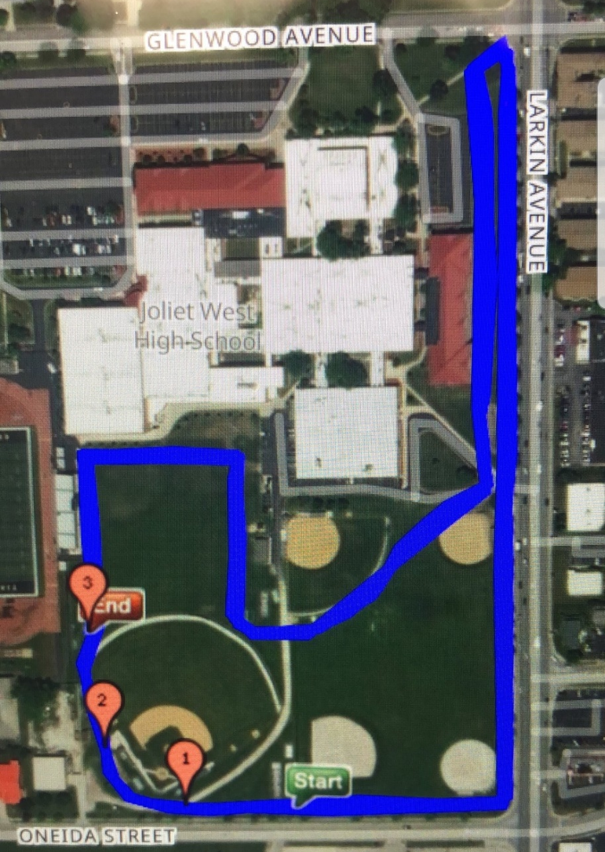
Course Map:

