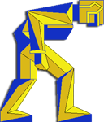

JOLIET CENTRAL
XC COURSE

CHANNAHON COMMUNITY PARK
MILE 1
MILE 2
MILE 3
FINISH
PARK DISTRICT
BUILDING
1 MILE
PARKING
SOFTBALL
DIAMOND
START
BUS
PARKING
PAVILION
CONCESSION BUILDING
2 MILE
PAVILION
PAVILION
PLAYGROUND
PARKING
SOFTBALL
DIAMOND

