2012
Southwest Prairie Conference
T-Shirt Pre-Order Form

Front (top) Back (bottom)
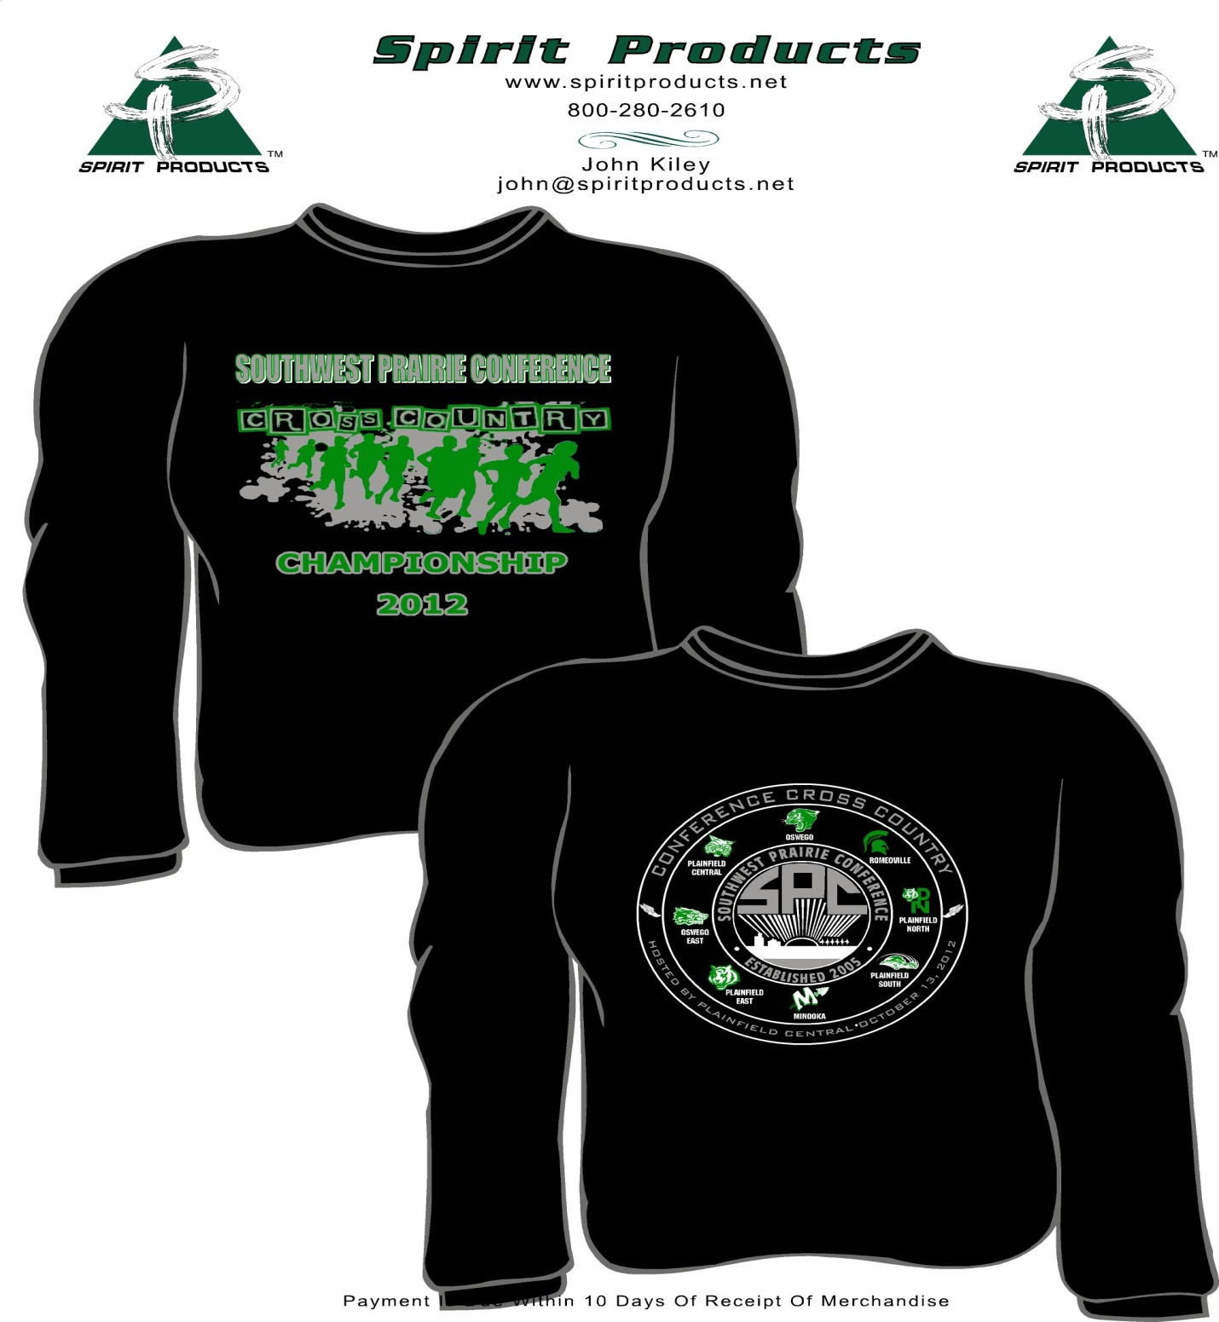Order form below.
$15.00 Each
School Name:
Coach Name:
Coach Email:
Size | Quantity | Price
SMALL
MEDIUM
LARGE
X-LARGE
XX-LARGE
TOTAL

