
LOCKPORT TOWNSHIP HIGH SCHOOL LOCKPORT TOWNSHIP HIGH SCHOOL

ATHLETIC DEPARTMENT
1333 EAST SEVENTH STREET, LOCKPORT, IL 60441
PHONE: 815-588-8150, FAX: 815-588-8159

BRIAN GOFF, ATHLETIC DIRECTOR
DONNA J. PATTISON, SECRETARY

Commitment to Excellence

LOCKPORT TOWNSHIP HIGH SCHOOL

IHSA CLASS 3A CROSS COUNTRY REGIONAL MEET INFORMATION

DATE: Saturday, October 20th, 2012

PLACE: Dellwood Park 2021 S. Lawrence Ave., in Lockport

PARTICIPATING TEAMS: Bolingbrook, Lockport, Neuqua Valley, Oswego East, Oswego, Plainfield Central, Plainfield East, Plainfield North, Plainfield South, Romeoville

TIME SCHEDULE:
8:30 am-9:15 am Packet pick-up finish area
9:15 am Course observers meeting
9:30 am Coaches meeting by end of finish chute
9:50 am National Anthem
10:00 am Girls Race (course closed to warm-up)
10:45 am Boys Race
11:15 am Awards and sectional information at the Tennis Courts
** If weather is a problem, we will move awards to Lockport Central Campus Gym

COURSE: Girls distance: 3.1 miles
Boys distance: 3.1 miles
Map may be found at http://www.athletics2000.com/lockport/ on left hand side and is included with this email.
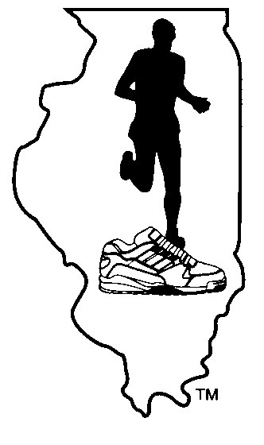
The course is, in every sense of the word a true cross country course with flat land,
hills, forests, and streams. The course is painted. Course inspectors will be
stationed at spots on the course for each race. They will be observing the conduct
of the runners and will be reporting race infractions at the conclusion of that race.
The course is in a public park and is open for practice any time it is light. If you wish a course tour, please call 815-588-8729 and leave a message. We will NOT be available for course tours after Wednesday, October 17th. IT IS YOUR RESPONSIBILITY TO ASK QUESTIONS ABOUT THE COURSE BEFORE THE RACE. Course markings will be standard flag code. Split times will be called at the mile and two mile mark for both races.

NO BICYCLES WILL BE ALLOWED ON THE COURSE DURING THE RACES.

FINISH CHUTE: Runners will finish in a chute 15’ wide at the mouth and 50’ long. The finish line will be at the mouth of the chute. The finish will be videotaped. Coaches should stress to participants not to push while moving through the chute after the race. Coaches and spectators need to STAY AWAY FROM THE FINISH END OF THE CHUTE.
TERMS AND
CONDITIONS: Please familiarize yourself with the IHSA regulations regarding the running of this series. This information is available in the Terms and Conditions at IHSA.org. Computer scoring shall be used. The (RFID) computer chips will be attached to the shoes using twist ties. Video review will be used.

EQUIPMENT: Contestants must meet all IHSA and National Federation clothing regulations. These are contained in the 2012 Track and Cross Country Rule Book and in the IHSA Terms and Conditions.

DRESSING: There are no dressing facilities at the park. Please come dressed to run.

RESTROOMS: Facilities are available at the park. There will be portable units adjacent to the start area.

MEDICAL AID: We shall have 2 athletic trainers on duty that day.

START: The starting procedure will be as follows:
10 minutes prior to race: Air horn sounds: clear start area; all competitors must report
5 minutes prior to race: Air Horn Sounds: all sweats must be removed for uniform inspection. Coaches must clear area. Runners will be brought to their marks by the blowing of a whistle and instructions given.

When field is set and ready the starter will fire the pistol. There will be NO VERBAL COMMANDS.

BOX ASSIGNMENTS: A blind draw for starting box position was held.

PARKING:
There will be no bus parking allowed in the park. After busses drop off their athletes, they are to go to Lockport Central High School and park around the building. The Lockport police have been alerted of the parking issue. Spectators may park in the lots at Dellwood for a fee of $5 per car regardless of the number of spectators-please car pool as space in the park is limited. Parking officials shall be on site to direct you.

NUMBERS: Numbers will be worn. Safety pins will be provided.

CHIP RETURN: The computer chips issued to each competitor must be returned to the meet management immediately after each race. Failure to return chips prior to leaving the park will result in the school being charged $10.00 per chip

SCORING: At least five runners from a team must finish in order to be eligible for team honors. When fewer than five runners from any team finish, the places of the runners from that school are disregarded when computing team scores. These runners may, however, receive individual awards.

AWARDS: A plaque will be presented to the winning boy’s team and the winning girl’s team. Individuals will receive awards for 1st to 10th place.

ADVANCEMENT: For both boys and girls, the first 7 teams shall advance to the sectional meet. The first 5 individuals who are NOT on one of the advancing teams shall also advance to the sectional meet.

ENTRIES: List of participants shall be obtained from the schools center once the deadline has passed on 10/16/12 at noon. Coaches are encouraged to bring a hard copy of their on-line list of participants.

CONCESSIONS: The Lockport Cross Country Boosters will be running a complete concession area.

TEE-SHIRTS: Minerva is pre-selling t-shirts and sweatshirts, go to
http://minervapromotions.com/lockport/

QUESTIONS: Please feel free to call:
Brian Goff:

815-588-8151 School; 815-588-8159 Fax
Tom Razo, Boys Head Coach 815-588-8729
Evon Schlotter, Girls Head Coach 815-588-8444

