

**Throws**

**Summer Training Packet 2014**

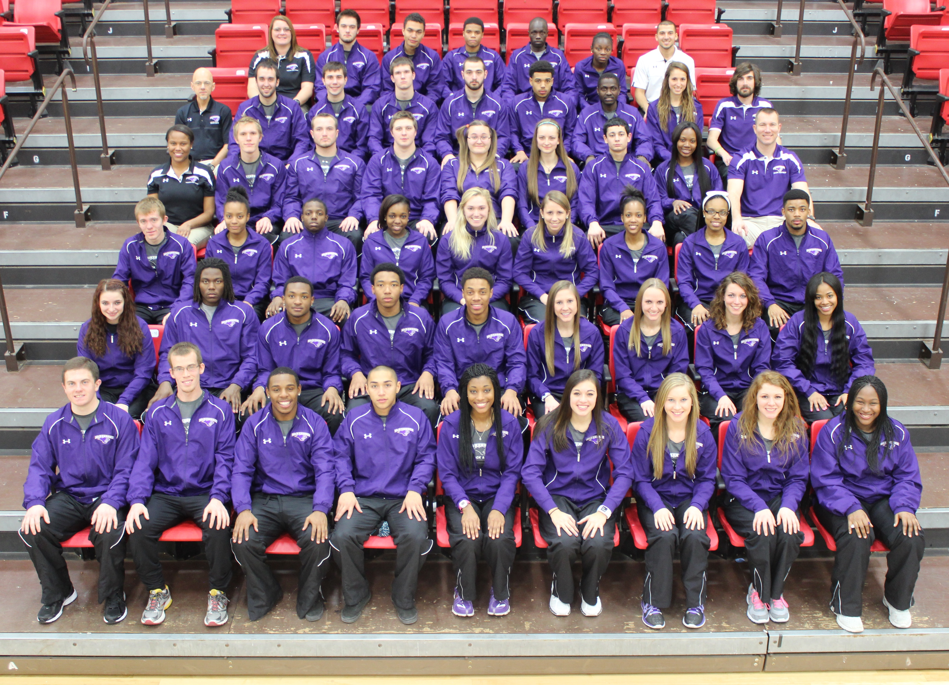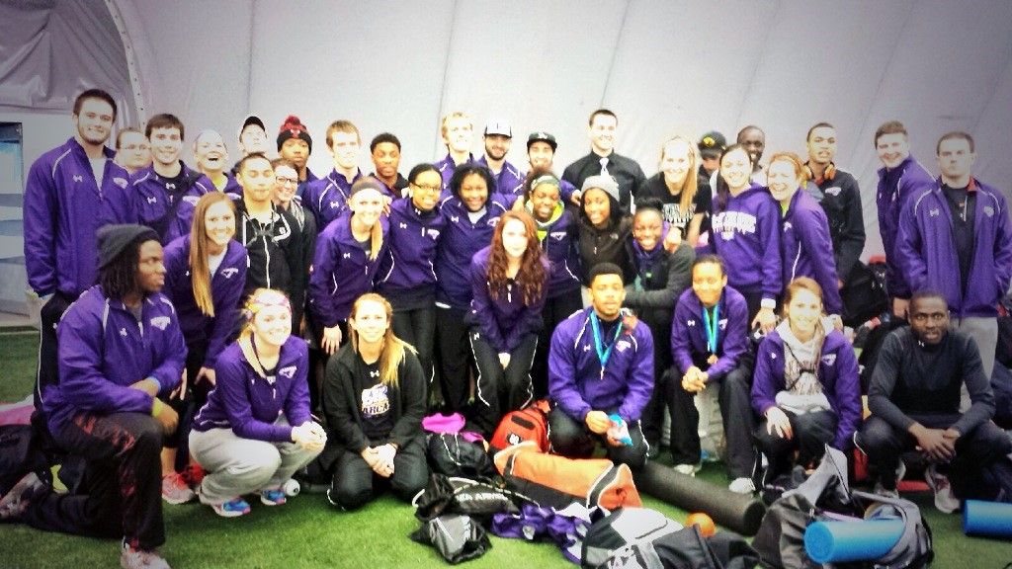

**&**

**Fall 2014/15 Info**



**Track Summer Training Information**

* ***All training in the summer is NOT Mandatory until Friday, August 29th. That is, all runs and workouts, should they not occur, will not have repercussions by the coach or institution****.*
* The recommended start date is June 2nd that coincides with the “plan.”
* Please take at least 2 weeks completely OFF after your last competition.
* You may use bearcatsxc.com to track your workouts throughout the summer.
* You must report for your physical appointment during the first week of classes in the fitness center. You must do so to practice.
* You MUST have proof insurance and proof of Sickle Cell Test before you may practice.
* The first Team meeting will be will be at 4pm on Thursday, August 29th meet in bleachers at Leemon Field!
* **NEWS FLASH!!! You will only ever be as good as you allow your body to recover… SLEEP, HYDRATE, EAT RIGHT**

**Avoiding Injuries**

* **Please do not “spike” your training at any time. That means do not train too hard too early!**
* **Keep track of your shoes. I am not a firm believer in the notion that we must all buy a shoe that is for our foot strike (pronation, etc.); however, if we are in shoes that are poorly constructed, cheap, or old…we WILL have problems.**
* **Do not skip workouts or tasks if you intend for it to “ALL COME TOGETHER.” In the training program, everything is there to ensure fitness and appropriate strength for the elite athlete. If we are to stay healthy and improve within ourselves, we must do it all and not cut.**
* **Be safe and keep the weather in mind!**

|  |  |  |
| --- | --- | --- |
| **KEY** | | |
| Abbr | Term/s | Definition/Science/Explanation |
| HT | Hammer Throw |  |
| WT | Weight Throw |  |
| SP | Shot Put |  |
| DS | Discus |  |
| JV | Javelin |  |
| Throws | Throw Crew |  |
| MB | Med Balls |  |
| W/U A | Warm Up A |  |
| W/U B | Continuous Warm Up |  |
| S | Strength |  |
|  | Activity | Basketball, swimming, tennis, etc. |
|  |  |  |

**Elements of the Training Program**

Think of your training in cycles. Each 3 weeks (following the first two intro weeks) have specific goals and aspects of training that allow your body time to adapt before the next cycle. Each cycle will have their own focus though they are not mutually exclusive… **THAT IS, EACH BUILDS ON EACHOTHER!!!**

|  |  |  |  |  |  |  |  |  |  |
| --- | --- | --- | --- | --- | --- | --- | --- | --- | --- |
| **Macrocycle 1**  **Jun 9–Nov 30 (25 weeks)** | | | | | **Macrocycle 2**  **Dec 1-Jun 7 (27 weeks)** | | | | |
| **Cycle 1**  **2 weeks** | **Cycle 2**  **2 weeks** | **Cycle 3**  **3 weeks** | **Cycle 4**  **3 weeks** | **Cycle 5**  **3 weeks** | **Cycle 1**  **3 weeks** | **Cycle 2**  **3 weeks** | **Cycle 3**  **3 weeks** | **Cycle 4**  **3 weeks** | **Cycle 5**  **3 weeks** |
| **6/09-6/22**  **Begin Activity**  **Introduction to training principles.**  **Preparation for base phase** | **6/23-7/06**  **Introduction to general development of strength, mobility, speed, and endurance** | **7/07-7/27**  **Development of strength, mobility, speed, and endurance** | **7/28-8/17**  **Recovery phase into introduction to progressions. Increase of intensity and frequency of workouts, plyometrics, and speed development (POWER=Strength + Speed!)** | **8/18-9/07**  **Recovery into fitness testing and evaluation phase at McKendree: MEET WITH HEAD COACH INDIVIDUALLY** | **12/1-12/21**  **Recovery week followed by suggested fitness maintenance over break** | **12/22-1/11**  **Maintenance of fitness**  **Brief training week into competition phase** | **1/12-2/1**  **Competition phase:**  **Achievement of qualification distances, etc.** | **2/2-2/22**  **Competition phase:**  **Achievement of qualification distances and personal bests**  **MEET WITH HEAD COACH INDIVIDUALLY** | **2/23-3/15**  **Championship Segment**  **NCAA Qualifying GLVC Conference Championships**  **NCAAs** |
| **Cycle 6**  **3 weeks** | **Cycle 7**  **3 weeks** | **Cycle 8**  **3 weeks** | **Cycle 9**  **3 weeks** | **END MACRO ONE** | **Cycle 6**  **3 weeks** | **Cycle 7**  **3 weeks** | **Cycle 8**  **3 weeks** | **Cycle 9**  **3 weeks** | **END MACRO TWO** |
| **9/08-9/28**  **Advanced development of strength, mobility, speed, and specific endurance: intro to Basic Technique** | **9/29-10/19**  **Development of specific fitness and advanced technical skill:**  **MEET WITH HEAD COACH INDIVIDUALLY** | **10/20-11/09**  **Development of specific fitness and advanced technical skill** | **11/10-11/30**  **Test of ability & improvement**  **Retest of fitness gains and losses evaluated.**  **FAST-CAT TRIALS**  **Establish indoor GOALS** |  | **3/16-4/5**  **Adjustment of technique**  **Preparation for and establish Outdoor season and goals** | **4/6-4/26**  **Competition phase: Achievement of qualification distances, etc.** | **4/27-5/17**  **Competition phase:**  **Achievement of qualification distances and personal bests**  **MEET WITH HEAD COACH INDIVIDUALLY** | **5/18-6-7**  **Championship Segment**  **NCAAs**  **Recovery Phase** |  |

*The following will be addressed in each of the cycles:*

**STRENGTH**

**SPEED**

**SKILL**

**ENDURANCE**

**FLEXIBILITY**

*Note: Power = Strength + Speed Agility = Skill + Speed Mobility = Flexibility + Skill*

|  |  |  |  |  |  |  |  |
| --- | --- | --- | --- | --- | --- | --- | --- |
| **SUMMER CALENDAR** | | | | | | |  |
|  | **June** | | | | |  |
| **Mo** | **Tu** | **We** | **Th** | **Fr** | **Sa** | **Su** |
| **2** | **3** | **4** | **5** | **6** | **7** | **8** |
|  |  |  |  |  |  |  |
| **9 (Cycle 1)** | **10** | **11** | **12** | **13** | **14** | **15** |
| Beginning Activity |  | Begin Activity |  | Begin Activity |  |  |
| **16** | **17** | **18** | **19** | **20** | **21** | **22** |
| W/U A  800m jog+stretch | W/U B  800m jog+stretch | W/U B  800m jog+stretch  PURPLE | W/U A  6x50m @95% w/1min rest  800m jog+stretch | W/U B  800m jog+stretch | W/U A  8x30m hill sprint w/ 2min rest  800m jog+stretch | OFF/R |
| **23 (cycle2)** | **24** | **25** | **26** | **27** | **28** | **29** |
| W/U B  LIFT DAY 1  800m Cooldown+stretch | W/U A  6x50m @95% w/1min rest  800m jog+stretch | LIFT DAY 2  W/U A  3 sets of 15xMedball chest push or pushups + 100m @ 90% 5min rest in between  800m jog+stretch | W/U B  800m jog+stretch | LIFT DAY 3  W/U A  40 x lightweight standing shotput throws with medball | 1 hour Activity (see key) + stretch | OFF/R |
| **30** |  |  |  |  |  |  |
| W/U B  LIFT DAY 1  10x no weight rotations while tired  800m Cooldown+stretch | |  |  |  |  |  |

|  |  |  |  |  |  |  |
| --- | --- | --- | --- | --- | --- | --- |
|  | **July** | | | | |  |
| **Mo** | **Tu** | **We** | **Th** | **Fr** | **Sa** | **Su** |
|  | **1** | **2** | **3** | **4** | **5** | **6** |
|  | W/U B  800m jog+stretch | LIFT DAY 2  W/U A  3 sets of 10xpushups,4xsquat jump, 50m sprint. 6min rest in between each set | W/U B  800m jog+stretch | LIFT DAY 3  W/U A  HOFFA  800m jog+stretch | 1 hour Activity (see key) + stretch | OFF/R |
| **7(cycle3)** | **8** | **9** | **10** | **11** | **12** | **13** |
| *LIFT DAY 1 (SEE LIFTING PACKET)*  W/U A  Accelerations- 3xpushup + Sprint Out: 8x10m; 4x15m; 1x20m  5xStanding Vertical Jump - 800m jog + stretch | W/U B  800m jog+stretch | *LIFT DAY 2 – AM*  AUX A. - PM | W/U B  NELSON  800m jog+stretch | *LIFT DAY 3*  W/U A  Single Leg glides:  3 sets of 10 @ 80% power | 1 hour Activity (see key) + stretch | OFF/R |
| **14** | **15** | **16** | **17** | **18** | **19** | **20** |
| *LIFT DAY 1*  W/U A  3 sets of 10xpushups,4xsquat jump, 50m sprint. 6min rest in between each set | W/U B  8x150m @ 70% w/ 30s  800m jog+stretch | *LIFT DAY 2 – AM*  AUX B. - PM | W/U B  CANTWELL + MARTIN  800m jog+stretch | *LIFT DAY 3*  3 sets of 10xchest light medball chestpush | 1 hour Activity (see key) + stretch  and light stretch | OFF/R |
| **21** | **22** | **23** | **24** | **25** | **26** | **27** |
| *LIFT DAY 1 (SEE LIFTING PACKET)*  W/U A  Accelerations- 3xpushup + Sprint Out: 8x10m; 4x15m; 1x20m  5xStanding Vertical Jump - 800m jog + stretch | W/U B  4x300m w/ 1min rest  BRENNER for Cool Down | *LIFT DAY 2 – AM*  AUX A. - PM | W/U B  NELSON  800m jog+stretch | *LIFT DAY 3 - AM*  800m W/U - PM  FnM1 | 1 hour Activity (see key) + stretch  and light stretch | OFF/R |
| **28(cycle4)** | **29** | **30** | **31** |  |  |  |
| FIVE DAY RECOVERY PHASE  OFF/R | **ALL:**  1 hour Activity (see key) + stretch | OFF/R | 1 hour Activity (see key) + stretch  and light stretch |  |  |  |

|  |  |  |  |  |  |  |  |
| --- | --- | --- | --- | --- | --- | --- | --- |
|  | **August** | | | | |  | |
| **Mo** | **Tu** | **We** | **Th** | **Fr** | **Sa** | | **Su** | |
|  |  |  |  | **1** | **2** | | **3** | |
|  |  |  |  | W/U A  Single Leg glides or GLIDE POP:  3 sets of 10 @ first 10 @ 80%, second @ 95%, third @ 80% | W/U A  PURPLE 5reps each + WHITE | | OFF/R | |
| **4** | **5** | **6** | **7** | **8** | **9** | | **10** | |
| *LIFT DAY 1*  W/U A  5x30m 3x40m 2x50m 1x60m  800m jog+stretch | W/U A  6x300m @ 70% w/ 2min rest.  20xmedball push or pushups. 5xslow, 5xfast, 5slow, 5xfast  800m jog + stretch | *LIFT DAY 2*  AUX A. - PM | 1 hour Activity (see key) + stretch | *LIFT DAY 3 - AM*  800m W/U - PM  FnM1 | W/U A  PURPLE 8reps each + WHITE | | OFF/R | |
| **11** | **12** | **13** | **14** | **15** | **16** | | **17** | |
| *LIFT DAY 1*  W/U A  5x30m 3x40m 2x50m 1x60m  800m jog+stretch | W/U A  6x200m w/ 3min rest. 2 hard, 2 relaxed, 2 hard  20xmedball push or pushups. 5xslow, 5xfast, 5slow, 5xfast  800m jog + stretch | *LIFT DAY 2*  CANTWELL + HOFFA | 1 hour Activity (see key) + stretch | *LIFT DAY 3 - AM*  800m W/U - PM  FnM2 | **Cross Country Moves In**  W/U A  PURPLE 12reps each + WHITE | | OFF/R | |
| **18(cycle5)** | **19** | **20** | **21** | **22** | **23** | | **24** | |
| Recovery Week  W/U B  Stretch | 1 hour Activity (see key) + stretch | 1 hour Activity (see key) + stretch | OFF/R | LIFT DAY 3  W/U B  Stretch | 1 hour Activity (see key) + stretch | | OFF/R | |
| **25** | **26** | **27** | **28** | **29** | **30** | | **31** | |
| FIRST DAY OF CLASSES | W/U A  Stretch | LIFT DAY 2  W/U B  6x30m @95%  800m jog+ stretch | Team Meeting 4pm Bleachers at Leemon Field | First Practice  3:30pm Meet at Track | 1 hour Activity (see key) + stretch | | OFF/R | |

|  |  |  |
| --- | --- | --- |
| **THROWS WARM UP** |  | **THROWS WARM UP** |
| **A (BEGINNING)** |  | **B (CONTINUING)** |
| 3-5min Running |  | Lunge + Twists |
| 50m Running Circuit |  | Walk Drills x 10 for 30m |
| *(Strides, Slides, Bckward)* |  | *StrgtLeg,Scps, Dplng, KneChst, HamPull* |
| Lunge + Twists |  | *Lng twist- Mrch: Fwd, Side, Side, Bckward* |
| Walk Drills x 10 for 30m |  | Pogo Sprints x 2 |
| *StrgtLeg,Scoops, Dplng, KneChst, HamPull* |  | *(Straight Leg and Quick)* |
| *Lng twist- March: Fwd, Side, Side, Bckward* |  | Single-Leg Power Jumps x 3 |
| Skip Drills x 10 x 30m |  | Shot/Discus Movements 2-3min |
| *Skips: Fwrd, SideX2, Bckwrd- Side Slide(SW)* |  | *5xDwnwrd pushes (Shot put)* |
| *KaraokeX2, Sngl Leg Swtch, FunnysX2* |  | THROWS (3 Total) |
| Standing Squats |  | *(Backward, Standing, Moving)* |
| Pogo Sprints x 2 |  |  |
| *(Straight Leg and Quick)* |  |  |
| Single-Leg Power Jumps x 3 |  |  |
| Shot/Discus Movements 2-3min |  |  |
| *5xDwnwrd pushes (Shotput)* |  |  |
| THROWS (3 Total) |  |  |
| *(Backward, Standing, Moving)* |  |  |
|  |  |  |

**GS Circuits, Cooldowns and Auxiliary Lifts**

|  |  |
| --- | --- |
| **NELSON** | **BARNES** |
| Push-ups regular | Rockets (6 count) |
| Chinnies | Side-ups |
| Back Hyper w/twist | Leg Circles In |
| Bicycle | Fondas |
| Push ups Wide | Low Level Bicycle |
| Pelvic Tilt (3 count) | Extenders |
| Reverse Sit up | Leg Circles out |
| Push-Ups Close | Chinnies |
| L-Over (M-L-R) | Side Leg Raise |
| 6” Scissors | Dbl Leg Eagles |
| Pelvic Tilt w/crunch | Pelvic Tilt (3 count) |
| Pelvic Tilt w/bicycles (8count) | Prone Hip Extension (str leg) |
| Back Extension | Superwoman |
| Lunge Good Morning |  |

|  |  |  |
| --- | --- | --- |
| **CANTWELL** | **MARTIN** | |
| Prone Hip Extension (straight leg) | Low Walk Forward | |
| Prone Hip Extension (bent leg) | Low  Walk Backwards | |
| Spotted Toe Touches | Low Walk Lateral (L&R) | |
| Double Leg Eagles | Lunge Walk | |
| V-Sit | Pushup Walk | |
| Push-Up Toe Walk | **GODINA** |
| Yogis | Heels Walk – Forward | |
| Reverse Yogis | Heel Walk – Backward | |
| Wrestler's Bridge | Toe Walk – Forward | |
| Toe Raises | Toe Walk – Backward | |
| Prisoner Squats | Inside Foot – Forward | |
| Decline Push-ups | Inside Foot – Backward | |
| Closed Squats | Outside Foot – Forward | |
|  | Outside Foot - Backward | |

|  |  |
| --- | --- |
| **HOFFA** | **WHITING** |
| Static Lunges (alternating) 1" off ground | Prone, Elbow Stand, Single Leg Raise |
| Easy Reverse Lunges 1" off ground | Supine, Elbow Stand, SL Raise |
| Front Lunge (opp side elbow - inside arch) | Prone, Hand Stand, SL Raise |
| Diag. Lunge (same side elbow - inside arch) | Supine, Hand Stand, SL Raise |
| Front Lunge (knee outside arms) | Lateral, Elbow Stand, SL Raise |
| Mountain Climbers (knee inside arms) | Lateral, Hand Stand, SL Raise |
| Mountain Climbers (knee outside arms) | Prone, Elbow Stand, Flex Knee, Hip Extension |
| Frog Thrusts (both knees outside arms - parallel) | Supine, Elbow Stand, Flexed Knee, Hip Extension |
| Wide Outs | Supine, Hand Stand, Big Circles - Inward |
|  | Supine, Hand Stand, Big Circles - Outward |
|  | Crunch, Low Reach |
|  | Crunch, Low Reach w/twist |

**BRENNER**

Rotations – Head, back, hip, & ankle

Butterfly

Pretzel

Knee to Chest

Knee Across

Hurdlers Stretch

Sit & Reach

Calf & Achilles

**AUXILLARY LIFTING**

**AUX. A AUX. B**

Eccentric Leg Extensions Single Leg Squats

Lunges Crossover Step-Ups

Eccentric Leg Curls Toe (Calf) Raises

Lunge Walks Arm Curls

Hyperextensions DB Lateral Raise

Shoulder Press Pull-Ups

Lat Pulldowns (behind head) Seated Russian Twist (on shoulders)

Dips Hanging L’s

Bent Over Rows Reverse Hyperextensions (Raise the Legs)

Hyperextensions w/ twist Glute – Ham Raise

Good Mornings Russian Twist w/ Lunge Walk

DB Alt. Toe Touches V-Sits

RDL (Romanian Deadlift) Russian Twist w/ ¼ Squat (Bar on Shoulder)

Russian Twist (overhead) Hanging Knee Lifts

|  |  |  |
| --- | --- | --- |
| **FORM AND MOBILITY** |  | **FORM AND MOBILITY** |
| **FnM1 (30-45min)** |  | **FnM2 (30-45min)** |
| Hip Flexor Push x 5 each Leg |  | Hurdles x 6-10hurdles |
| Giant Walking Lunge x 50m |  | *Walkover strght, bckward x 2 each leg* |
| Single-Leg Running x 40m E.L. |  | *Full Overs Fwd Bckwd x 2 each, OVR/UNDR* |
| Hill Sprints x 8 Seconds |  | *Sideways Strght leg, bent leg* |
| Single-Leg Pistol Squat |  | Myrtle x 10 each |
| 3-Way Calf Raises x 10 each dir. |  | *Clams, Lateral Raises Toe in, neu, out, Dnky,* |
| Superman x 10 x 3 Way |  | *Dnky whip, fire hy, kne cir fw/bck, STAND..* |
| Myrtle |  | *Ltrl Leg, Lin Leg, Lin Bent* |
| *Clams, Lateral Raises Toe in, neu, out, Dnky,* |  | Body Weight x 15 each |
| *Dnky whip, fire hy, kne cir fw/bck, STAND..* |  | *Superman, Normal Situp, V-Sit, Strght leg* |
| *Ltrl Leg, Lin Leg, Lin Bent* |  | *Crunches, Twisting Situp, Superman twst,* |
| Lunge Matrix |  | *Iron Cross, Windshield Wipers, Leg Clmbr* |
| *Frnt, angle, Side, Angle, Bckward (Switch)* |  | Skip Drills x 10 x 50m |
| Drills-x 50m |  | *Skips: Fwrd, SideX2, Bckwrd- Side Slide(SW)* |
| *A-Skip, B, C, High Knee, Butt Kick* |  | *KaraokeX2, Sngl Leg Swtch, FunnysX2* |
| *Fwd, Bckwd, Sideways, Strght legs, Fast legs* |  | Planks-30s Each Moving Throughout |
| *Sidwys swipe+slide, Karaoke high, ovr* |  | *Forward, Side, Side, Backward x 2* |
|  |  |  |

|  |  |  |
| --- | --- | --- |
|  |  |  |
| **CHAMPION** |  | **PURPLE** |
| 1. Iron Cross |  | 1. Double Leg Pogo (Front/Back) (Left/Right) |
| 2. Windshield Wipers |  | 2. Straight Leg Pogo (Front/Back) (Left/Right) |
| 3. SL Crunches |  | 3. Tuck Jump |
| 4. Superwoman |  | 4. Switch Jump |
| 5. Suitcases |  | 5. Squat Jump |
| 6. V-Sits |  |  |
| 7. Elevated feet-raise hips |  | **WHITE** |
| 8. Bicycles |  | 1. 10X Power Skip Vertical |
| 9. Normal Sit Up |  | 2. 3X5 Hurdle Hops |
| 10. Med Balls |  | 3. 5 Box Jumps |
|  |  | 4. 5X2 Squat Jumps |
| **NEVADA** |  |  |
| 1. Front-elbows |  | **VEGAS** |
| 2. Right Side (elbows) |  | 1. 5 Standing LJ |
| 3. Left Side (elbows) |  | 2. 5 Standing TJ |
| 4. Back (elbows) |  | 3. 3X3 Double Leg Hops |
| 5. Front (hands) |  | 4. SL 2X LLRR |
| 6. Right Side (hands) |  | 5. SL 2XRRLL |
| 7. Left Side (hands) |  |  |
| 8. Back (hands) |  |  |

**IMPORTANT DATES/SCHEDULE FALL 2014**

September 5th - XC- USI-Steggemoller Classic

September 7th - VOLUNTEER – RAMS GAME NOON

September 12th – XC – SIUE

September 21st - VOLUNTEER – RAMS GAME NOON

October 5th - XC- Greater Louisville Classic Louisville, KY

October 11th - XC- LEWIS

October 13th - VOLUNTEER – RAMS GAME 7:30pm

October 15th – JOG-A-THON

October 19th - VOLUNTEER – RAMS GAME NOON

October 25th - XC- Home or Pre-Regionals or Off

November 8th - XC- GLVC Championships Lewis Romeoville, IL

November 16th - VOLUNTEER – RAMS GAME NOON

November 20th and 21st Fast-Cat Trials (Intersquad vs. Alumni) Lebanon, IL

November 22nd - XC- NCAA CC Midwest Regionals – USI Evansville, IN

November 30th - VOLUNTEER – RAMS GAME NOON

December 6th - XC- NCAA Division II Nationals Louisville, KY

December 6th – TF – PRINCIPIA?

December 11th – VOLUNTEER – RAMS GAME 7:25pm

December 21st – VOLUNTEER – RAMS GAME 3:05pm

**IMPORTANT DATES/SCHEDULE SPRING 2015**

January 7th – ALL – Move-In

January 9th - TF – MIZZOU (PARTIAL TEAM)

January 17th – TF – LEWIS (FULL TEAM)

**MCKENDREE UNIVERISTY**

**FALL 2014 ACADEMIC CALENDAR**

Monday, August 4 August Four-Week Classes Begin

Saturday, August 30 August Four-Week Classes End

**August 20-24, 2014 New Student Orientation**

Monday, August 25 Classes Begin

Friday, August 29 Last day to withdraw from a course with a 100% refund

(5th day of class) Last day to add a course*

Last day to withdraw from a course without receiving a “W”*

*Monday, September 1 Labor Day – No Classes (Saturday classes will meet on Saturday)*

Tuesday, September 8 Last day to withdraw from a course with a 75% refund

(10th day of class)

Monday, September 22 Last day to withdraw from a course with a 50% refund

Thursday, October 16 1st Half Semester Classes End

*Friday, October 17 Fall Break – No Classes*

Monday, October 20 2nd Half Semester Classes Begin

October 24 – 26 Homecoming

Tuesday, November 4 Last day to withdraw from a full semester course

(50th day of class)

*November 26-30 Thanksgiving Holiday – No Classes (Wednesday – Sunday)*

Friday, December 5 Last Day of Regular Class Sessions

**December 8-11 Final Exams (Monday - Thursday)**

*These dates apply to full-semester courses. Please see half-semester calendars for one-month, six-week and eight-week withdrawal dates

This calendar and future calendars are available on the McKendree web site:

http://www.mckendree.edu/offices/academic-records/academic-calendar.php